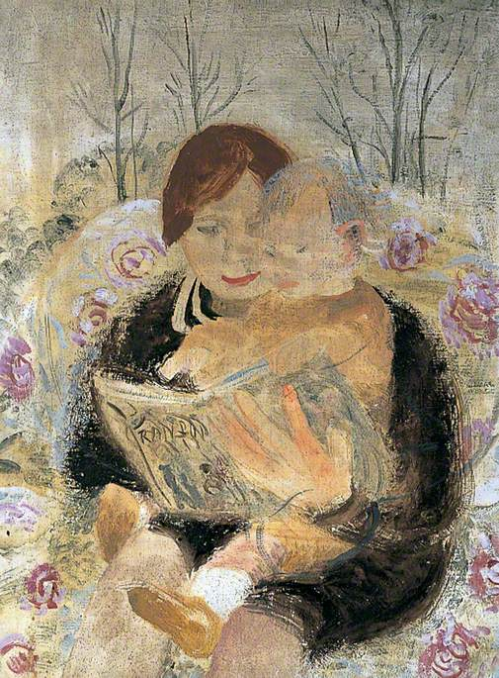
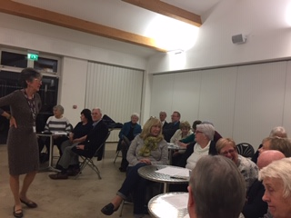
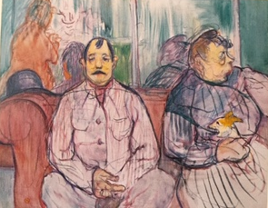
DAY TWO The Living Room

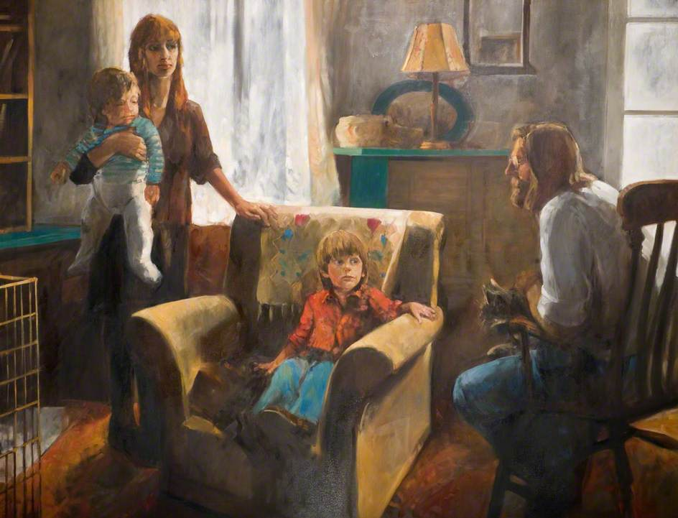
Make each place special for a day by placing a symbol in the room being blessed. This could be a candle (careful if there are children in the house), a family photo, a significant ornament or statue, a cross, a vase of flowers etc… This will help to bring your attention to that place each time you pass or enter.

Jesus said: Make your home in me as I make mine in you. (John 15: 4)

We give thanks for the gift that is home,
We bless the one who gave us life that we might experience love
We bless the ones with whom we live and share that love.
We bless this day and watch for the blessings it holds in wait.
We bless those we know and love now in their own homes.
May we always be truly grateful and ever-loving good Lord. Amen.

As a child I can remember we had the luxury of two living rooms, one was called the ‘front room’, that’s where our first TV was, and we children were expected to keep to this room. The ‘lounge’ was different; it was reserved for grown-ups and ‘special guests’ and was kitted out with the very best 1970’s look. On those rare occasions we were admitted we had to wear our slippers. A living room represents relaxation, a safe space where we can be ourselves, a place we have to negotiate with other members of the family about what to watch, who sits where, or these days, whether it’s permitted to bury our heads in smart phones.

It’s also the place where visitors gain access for a while to the inner sanctum of the family. Tea is served (best china if the guest is regarded as worthy of such an honour). Or if this is a living room kitted out with its own bar or cocktail cabinet, something else might be offered.
At its best our living room lives up to its name as a place where we talk, share news, share troubles, resolve matters of disagreement or sit contentedly in that homely silence where being together is enough.

It might be called the ‘living’ room but in some cultures, it can become a temporary shrine for the dead when the body of a deceased family member spends the last night before the funeral. The coffin’s unavoidable presence intrudes on one kind of normality to replace it with another as we remind one another of our loss and our blessings. As we recall such memories they draw out tears and laughter in equal measure, bestowing as if by magic the reassurance we all need that death is not the end.

Even if we don’t follow this ritual the living room remains a place in which our memories and relationships are enshrined in picture frames. The “Family Gallery” is a particularly egalitarian feature of a living room allowing the generations exist side by side. For along with images of generations past hang celebratory photos of more recent generations (maybe including a professionally taken family portrait photograph), a holiday snap or a graduation pose, images that remind us of our experiences, achievements and our validate our pride. Good things to cherish.

Let us build a house where prophets speak,
And words are strong and true,
Where all God’s children dare to seek
To dream God’s reign anew.
Here the cross shall stand as witness
And as symbol of God’s grace;
Here as one we claim the faith of Jesus.
All are welcome, all are welcome,
All are welcome, in this place.
(Marty Haugen © GIA Publications)

Here in this place,
may we know that we are truly valued,
Our thoughts respected and our memories shared.
Here may we open our hearts and minds
To listen and to learn, to own our mistakes
And gain forgiveness.
So we bless the one who calls us his children,
We bless the ones who bear Christ’s name
We bless those who share our stories. Amen

Crafty Kids: Saint Matthew thought it was important to let us know the names of Jesus’ ancestors. The family that Saint Joseph was part of was rather famous because it included a very famous person who first became known as a boy when he stood up to someone much bigger that him who was threatening everyone. This boy later became King David and although he lived a long time before Jesus his family were always proud of him.

If you go into some old churches you might see a big window with a picture of a tree that starts at the bottom with King David’s father whose name was Jesse. The tree grows from the side of Jesse and in its branches there are pictures of King David and of some of the other ancestors of Jesus and in the very middle or at the top comes a picture of Jesus being held by his mother Mary. These windows or sometimes paintings on walls are known as a Jesse Tree. It’s the Family Tree of Jesus.

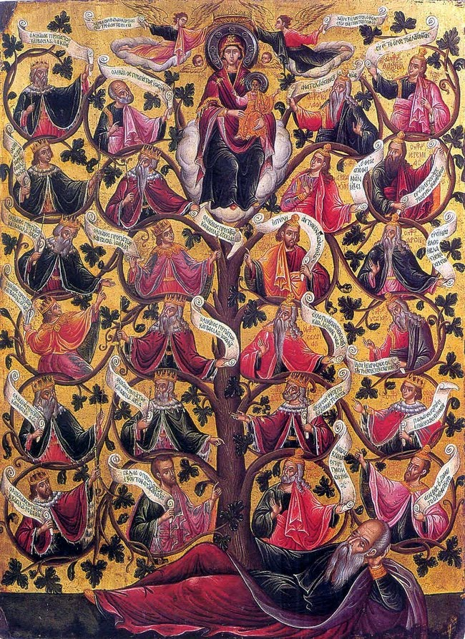

So how about making your own Family Tree with a trunk and lots of big sturdy branches, enough to draw a picture or put a photograph of the people in your family. Like the Jesse Tree it can include people from the past. This becomes your very own Family Tree.

Notes on the Artworks

Monsieur, Madam et le chien (1893) by Tolouse-Lautrec could be set in a public lounge as there are more people present than the main two characters and their dog. But it might easily be a domestic scene with no obvious communication between the man and the woman who cradles the dog in her lap.

Next comes a piece by Bridget MacDonald who presents us with a classic late C20th century image of family, hence the title, Family Group (1980-88). Two adults and two children, but how did the young boy acquire the armchair? Who is left holding the baby? Has the man struggled to let go of the 1970’s?

Parish life requires more than the annual and weekly cycle of worship with its engrossing revisiting of the mysteries of Christ’s life, death and resurrection. The church that gathers, are the people who accept or at least intuit that the significance and value of Christ’s proclamation of God’s kingdom is also to be found in the everyday exchanges and relationships of human community. We belong with and for one another. Sometimes our needs are profound, complicated, even troubling, and a community of faith at its best offers at least some degree of comfort, solidarity and support; but we also receive more subtly from each other in the social, charitable, devotional and educational encounters that also form part of parish life.

Janet and Jacob by Winifred Nicholson (1929) poses fewer questions that the first two pieces. Many of us have been a Janet and Jacob; as child being held and entertained with a story and as an adult taking pleasure in such moments of one to one intimacy, our minds wandering beyond the story oin the page and imagining the future story yet to unfold in a life just starting out.

Sorry to say I have no information to provide on the image of a Jesse Tree however it acts as a good example of the type.

©Peter C Montgomery 2020

